NodeMCU (ESP-12E)
It is build using the ESP8266 SoC Wi-Fi and hardware based on the ESP-12E module.
- Pin Definition

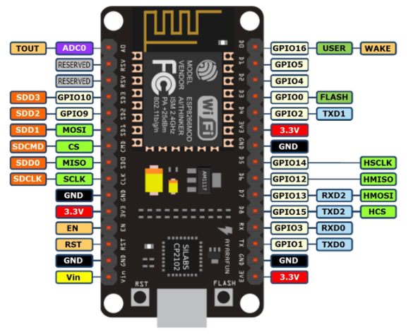
Note: Vin (5V)

- General Specifications

Wireless standard | IEEE 802.11 b/g/n
Frequency range | 2.412 – 2.484 GHz
Peripheric | UART, I2C, PWM, GPIO, 1ADC
Operation voltage | 3.3 V
Output current per GPIO pin | 15 mA
Working current | 12 – 200 mA
Standby current | 200 uA
Flash memory | 512K
Processor | Xtensa Single-core L106 32 bits
Processor speed | 80 – 160 MHz
GPIO | 17 (multiplexed with other functions)
ADC | - of 10 bits
PWM Signals | 8
SPI/I2C/I2S/UART | 2/1/2/2

- Interfaces

Interface | Pin Name
HSPI | GPIO12 (MISO)  GPIO13 (MOSI)  GPIO14 (CLK)  GPIO15 (CS)
ADC | TOUT
I2C | GPIO14 (SCL)  GPIO2 (SDA)
UART | UART0:  TXD (U0TXD)  RXD (U0TXD)  GPIO15 (RTS)  GPIO13 (CTS)  UART1:  GPIO2 (U1TXD)
I2S | I2S Input:  GPIO12 (I2SI_DATA)  GPIO13 (I2SI_BCK)  GPIO14 (I2SI_WS)  I2S Output:  GPIO15 (I2SO_BCK)  GPIO13 (I2SO_DATA)  GPIO2 (I2SO_WS)

Pins Arduino: https://github.com/esp8266/Arduino/blob/74819a763bfb6e9890a57411dcea4aba221a778d/variants/nodemcu/pins_arduino.h

- Arduino Library documentation
  - Digital IO
All 16 GPIOs can be used as INPUT, OUTPUT, INPUT_PULLUP

pinMode (GPIOx, mode)
digitalRead(GPIOx)
digitalWrite (GPIOx, HIGH/LOW)

  - Interrupts
Pin interrupts are supported through attachInterrupt, detachInterrupt functions. Interrupts may be attached to any GPIO, except GPIO 16. Arduino support CHANGE, RISING and FALLING interrupt types.

  - Timing and delays
millis() and micros() return the number of millisecond and microseconds elapsed after reset, respectively.

delay(time_in_ms) and delayMicroseconds(time_in_us) both pause the sketch for a time.

  - Analog output
PWM can be used on pins 0 to 16. It is 10-bit interface from 0 to 1023). By default, frequency is set at 1kHz and It can be changed from 100Hz up to 40000Hz. The ESP does not have hardware PWM, so its implementation is by software.

analogWrite(GPIOx, value)
analogWriteFreq(new_frequency)

  - Serial
Serial uses UART0, which is mapped to pins GPIO1 (TX) and GPIO3 (RX). Serial1 uses UART1, TX pin is GPIO2; this UART only can transmit dt

All the functions and interfaces available in Arduino library can be found here:
https://arduino-esp8266.readthedocs.io/en/2.5.2/index.html

- Arduino IDE Setup and Hello World

The proper setup can be found in the page number 4 here: https://www.handsontec.com/pdf_learn/esp8266-V10.pdf

Source:
https://einstronic.com/wp-content/uploads/2017/06/NodeMCU-ESP8266-ESP-12E-Catalogue.pdf
https://makeradvisor.com/esp32-vs-esp8266/
https://iotbytes.wordpress.com/nodemcu-pinout/
https://www.kloppenborg.net/images/blog/esp8266/esp8266-esp12e-specs.pdf
https://github.com/esp8266/Arduino

